TRAFFICVIOLATION MANAGEMENT

SOFTWARE ENGINEERING

THESIS

Version : 3.2

GROUP NAME: SE06
GROUP MEMBER:
1.Nguyễn Bảo Linh.
2.Trần Anh Duy.
3.Đỗ Quang Huy.

REQUIREMENT TEMPLATE CHANGE LOG
Version | Description | From | To
3.0 | Demo System design document. | April 4,2020 | April 6,2020
3.1 | Discussing and editing to have the final product. | April 7,2020 | April 8,2020
3.2 | Update the last version of report follow the comment of instructor. | April 30,2020 | May 1,2020

PRODUCT CHANGE LOG
Version | Description | From | To
3.0 | Demo depend on SRS in item section 1 and section 2 ,proceed painting diagram in item section 3 and section 4. | April 4, 2020 | April 5,2020
3.0 | Draw diagram in section 5. | April 5,2020 | April 6,2020
3.1 | Discuss about problems in document ad editing to have the final product. | April 7,2020 | April 8,2020

ASSIGNMENT
Full Name | Task
Nguyễn Bảo Linh | Design database, section 1 and section 2, use cases.
Đỗ Quang Huy | Design interfaces.
Trần Anh Duy | Design section 5.

Table of contents
TRAFFIC VIOLATION MANAGEMENT 1
SOFTWARE ENGINEERING THESIS 1
Version 3.2 1
1. Introduction 4
1.1 Purpose 4
1.2 Scope 4
1.3 Definitions and Acronyms 4
1.4 References 4
2. Overall Description 5
3. Project Plan 6
3.1 Project Organization 6
3.1.1 Team Structure 6
3.1.2 Roles and Responsibilities 6
3.2 Detailed Plan 6
4. Analytics and Design 7
4.1 System Analytics 7
4.1.1 Use Cases 7
4.1.1.1 Actors 7
4.1.1.2 Use Case Diagrams 7
4.2 System Design 12
4.2.1 Design Overview 12
4.2.2 Detailed Design 12
4.2.3 Database Design 15
4.2.3.1 Database Scheme 15
4.2.3.2 Database Table Definition 16
4.2.4 User Interface Design 18
5. Specific Requirements 20
5.1 Functionality 20
5.1.1 Login function 20
5.1.2 Register function 20
5.1.3 User function 21
5.1.4 Admin function 21
5.2 Reliability and Security 21
5.3 Backup and Restore 21
5.4 Interfaces 22
5.4.1 User Interfaces 22
5.4.2 Hardware Interfaces 22
5.4.3 Software Interfaces 22
6. Implemention 23

Introduction

Purpose
This document will shown a more detailed overview then Software Requirements Specification. We can visualization exactly functions, interface of system, and how system work.

Scope
After written SRS my team have specify for scope of product. Let visualization we have a null database and software and below is procedure to use we can understand like scope of use :
- Manager ( here is the police) insert data members have transport and driver license through a excel file with a format to database.
- Manager update violates of transport in excel file.
- Manager use functions as delete, update, search ,… to manage data.(details below)
- Manager use functions as delete, update,… to manage user.(details below)
- Manager update laws document through a world file.
- User who have transport and driver license create account with number of driver license.
- User query data violates from database through system after login.
- User communication with manager with a chat basics chat offline.
- User recover pass when forgot through function forget pass.
- User read laws document in laws document interface.

Definitions and Acronyms
Software Requirements Specification | SRS

References
- We refer a few post in Techblog.vn.
- The document traffic law in www.mt.gov.vn.

Overall Description
Below is the diagram overall description system with environment system.
Note : Management activities include :
- Insert.
- Query.
- Delete
- Update.(Repair)
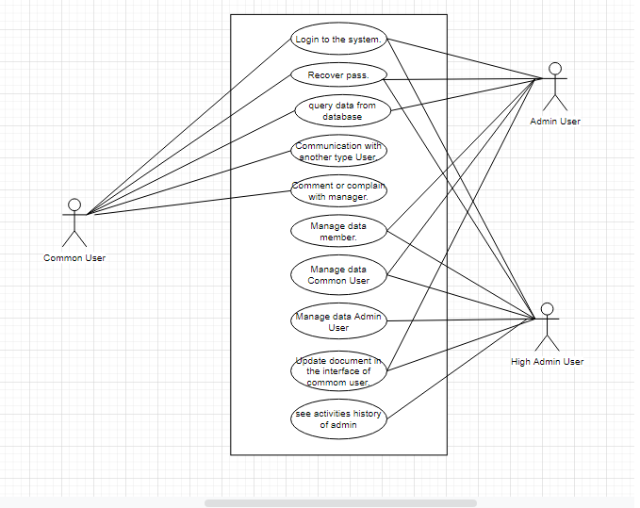
Gantt chart

Project Plan

Project Organization

Team Structure
- There are three peoples en my team, about Linh (leader) , Duy and Huy (member).
- We study in the same class in university and come from another country.
- Linh is leader and he good at database design.
- Duy and Huy good at use framework of C# .NET.

Roles and Responsibilities
Linh
Database design, code database, connect database, Installer software
Duy
Code functions and handling exceptions.
Huy
Design, code interface and handling exceptions.

Detailed Plan
Below is my team Gantt chart.

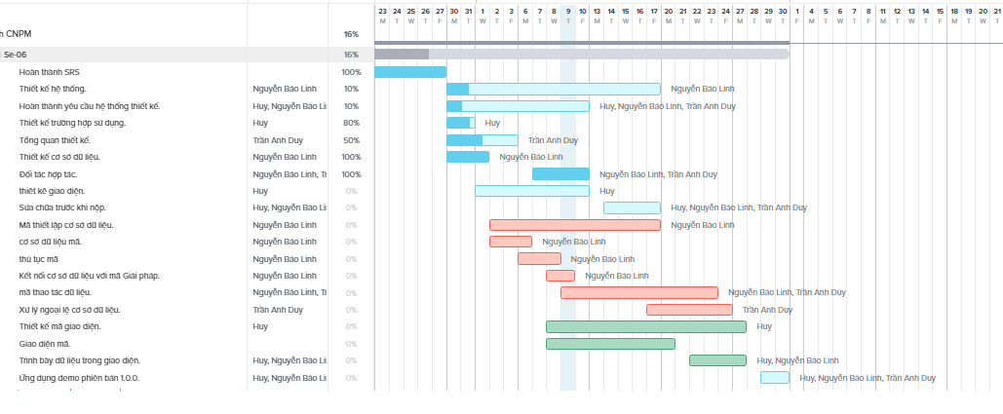
Gantt chart

Analytics and Design

System Analytics

Use Cases

Actors
- We have three kinds of user will be invoked in this system :
  - Common User : member have information in system, people use information they have to register and login system as required.
  - Admin : They are the manager of system, they will be grant a account by high admin to login and use functions in system.
  - Super Admin : this is the senior manager , they manage admin and can use all functions that admins can use, their account will be grant by system, developer.

Use Case Diagrams
- Overall system diagram.
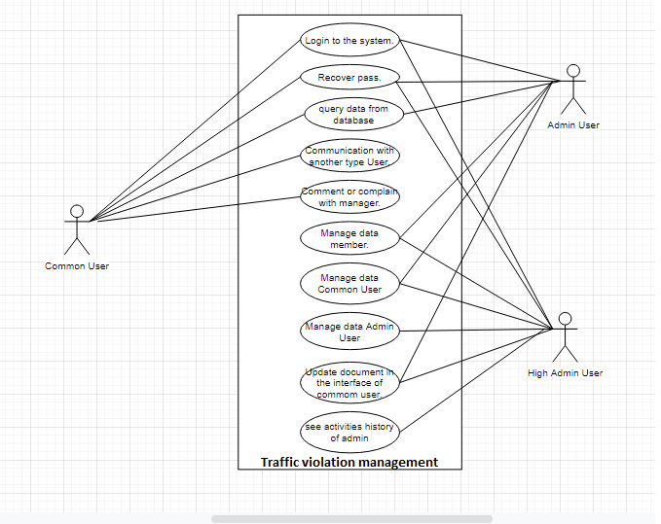

Overall system diagram
- Detailed diagram :
  - Common User :
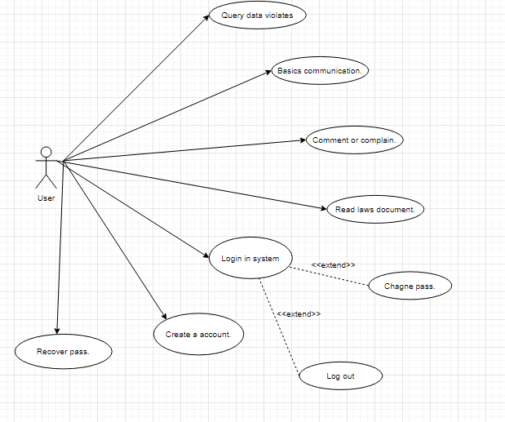
Common user diagram

  - Admin :
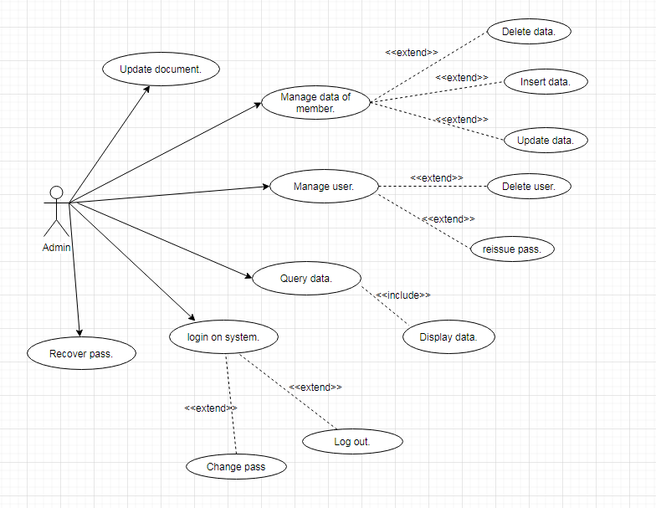
Admin diagram

  - High Admin :

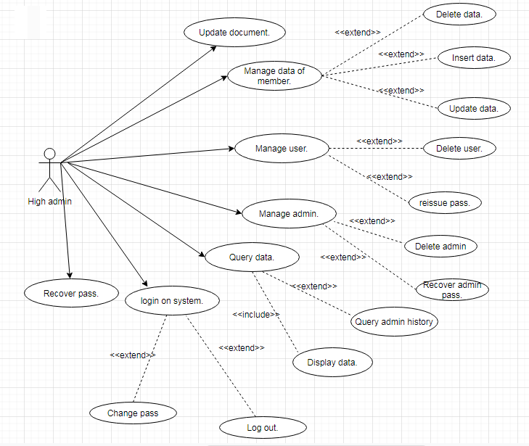
High admin diagram
- Activity diagram :
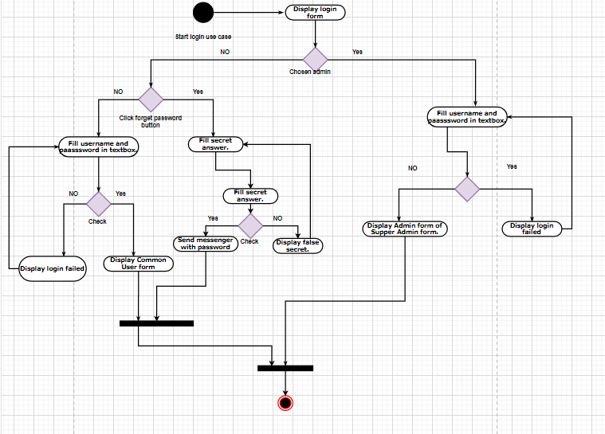
Login diagram

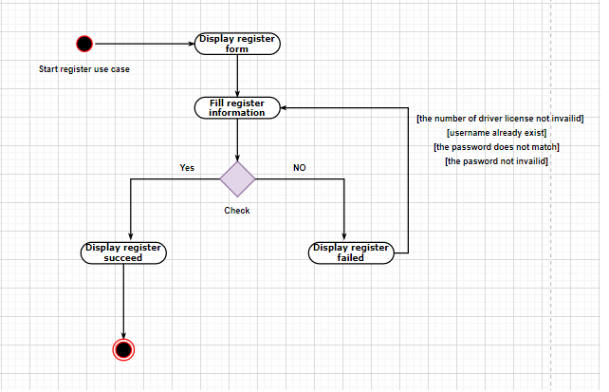
Register diagram
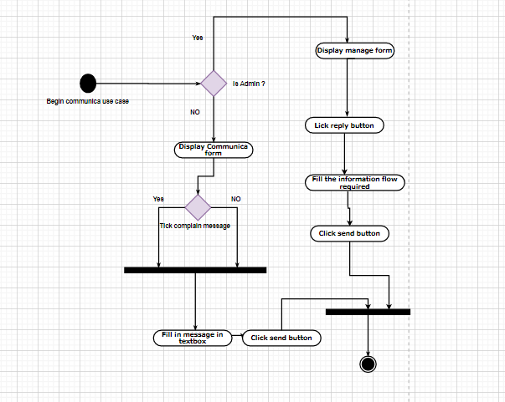
Communica diagram
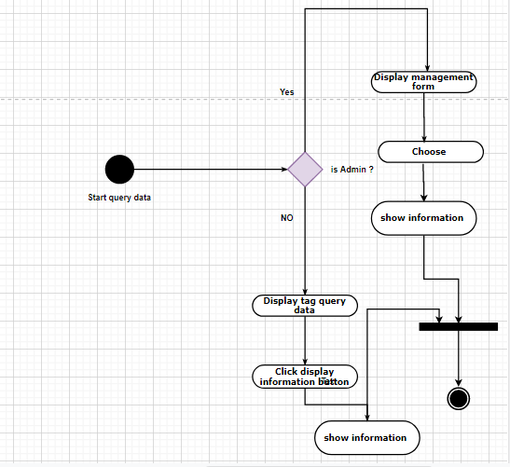
Query data diagram
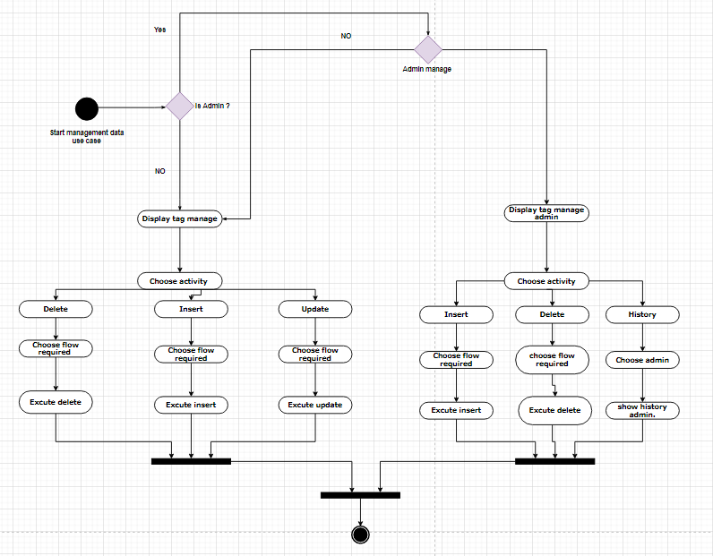
Manage diagram

System Design

Design Overview
- System flow with components :
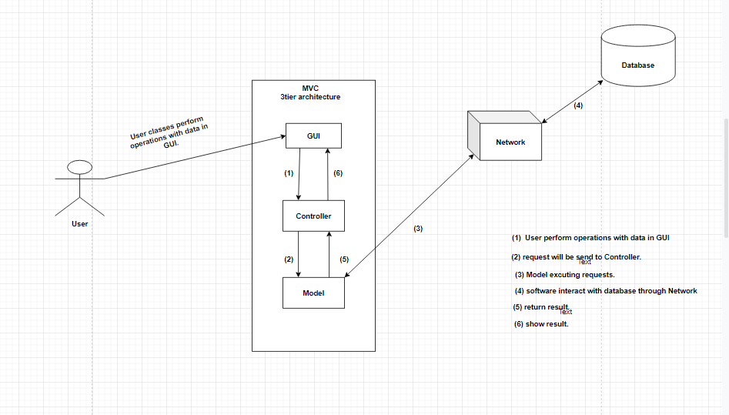
System flow with components diagram

Detailed Design
- Package Diagram.
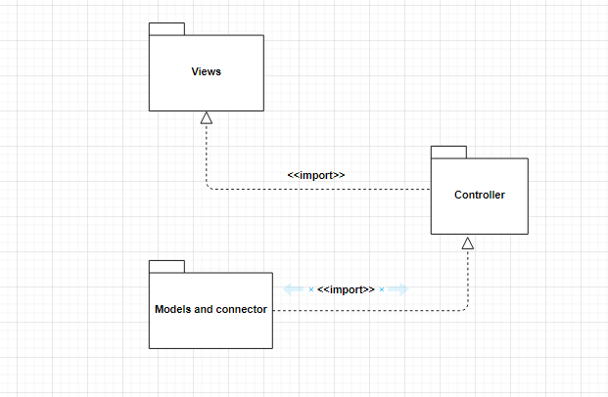
Package diagram

- Class Diagram
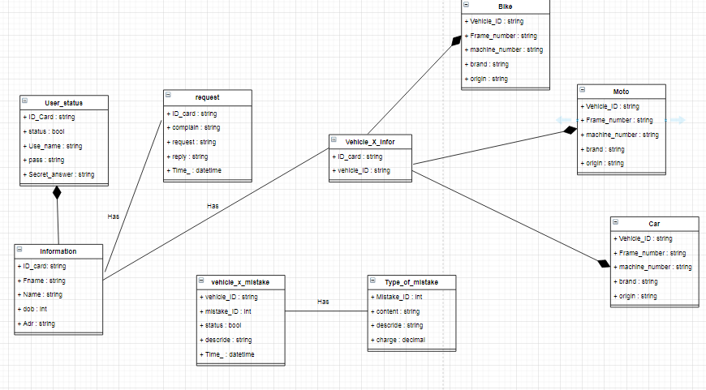
Class diagram

- Class Description
  - Model : this include classed abstraction object to property .
  - Connector : this class have ManageMethod() this represent to all manage function in this system, include update, insert, delete, query . per a class of model we have one manage corresponding method .
  - Controller : Controller is medium class between model and connector , connector call methods in Controller to interative with Model.

- Sequence Diagrams

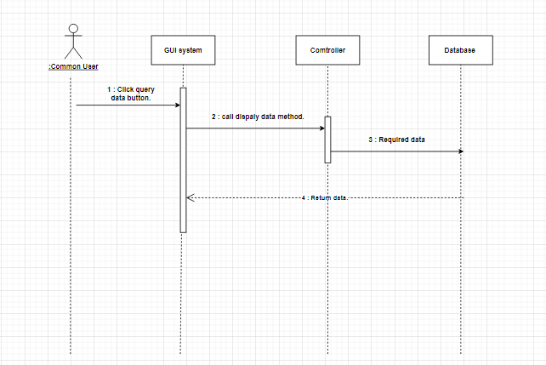
User Sequence Diagram

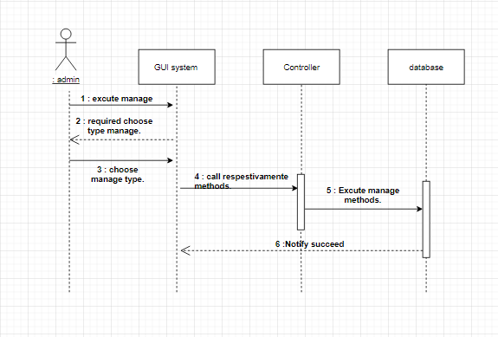
Admin Sequence Diagram
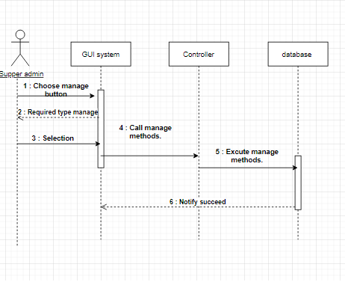
High admin Sequence Diagram

Database Design

Database Schema
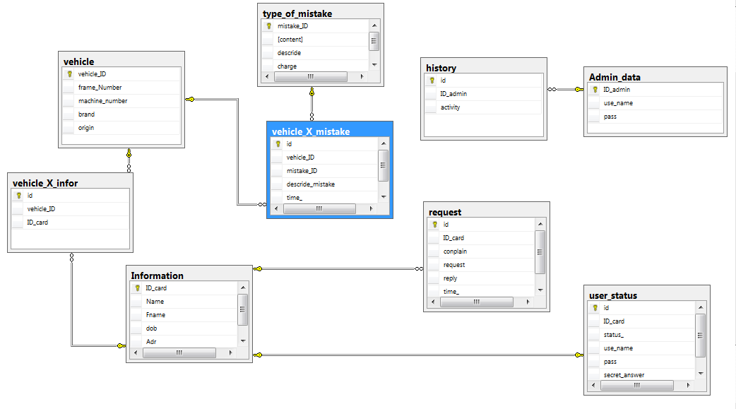
Database schema

Database Table Definition
- Admin_data
Column Name | Data Type | Allow Null | Indexes | Description
ID_admin | int | No |  | Code of admin
Username | nvarchar(100) | No |  | Name of account admin
Pass | nvarchar(30) | No |  | Password of account admin
- Vehicle
Column Name | Data Type | Allow Null | Indexes | Description
Vehicles_ID | Varchar(20) | No |  | Number of vehicles
Frame_Number | Nvarchar(20) | No |  | Frame number of vehicles
Machine_nunber | nvarchar(20) | No |  | Machine number of vehicles
brand | nvarchar(50) | No |  | Brand of vehicle
Origin | nvarchar(50) | No |  | Origin of vehicle
- Information
Column Name | Data Type | Allow Null | Indexes | Description
ID_card | Varchar(20) | No |  | Number of driver license
FName | Nvarchar(50) | No |  | Frame number of vehicles
Name | nvarchar(50) | No |  | Machine number of vehicles
dob | int | No |  | Brand of vehicle
Adr | nvarchar(100) | No |  | Origin of vehicle
- history
Column Name | Data Type | Allow Null | Indexes | Description
ID_admin | Varchar(20) | No |  | Number of admin
activity | ntext | No |  | Activity of admin
- request
Column Name | Data Type | Allow Null | Indexes | Description
ID_card | Varchar(20) | No |  | Number of driver license
Complain | ntext | Yes |  | Complain of user
request | ntext | Yes |  | Request of user
reply | ntext | Yes |  | Reply of admin
Time_ | datetime | No |  | Origin of vehicle
- Type_of_mistake
Column Name | Data Type | Allow Null | Indexes | Description
Mistake_ID | int | No |  | Code of mistake
Content | ntext | No |  | Content of mistake
describe | ntext | No |  | Description of mistake
Charge | Money | No |  | fine
- User_status
Column Name | Data Type | Allow Null | Indexes | Description
ID_card | Varchar(20) | No |  | Number of driver license
status | bit | No |  | Frame number of vehicles
Use_name | varchar(100) | Yes |  | Machine number of vehicles
Pass | Char(32) | Yes |  | Brand of vehicle
Secret_answer | ntext | Yes |  | Origin of vehicle
- Vehicle_X_infor
Column Name | Data Type | Allow Null | Indexes | Description
ID_card | Varchar(20) | No |  | Number of driver license
Vehicles_ID | Varchar(20) | No |  | Number of vehicles
- Vehicle_X_infor
Column Name | Data Type | Allow Null | Indexes | Description
Vehicles_ID | Varchar(20) | No |  | Number of vehicles
Mistake_ID | int | No |  | Code of mistake
Status_ | bit | No |  | Has the fines been paid yet ?
Describe_mistake | ntext | No |  | Describe mistake
Time_ | datetime | No |  | Time

User Interface Design
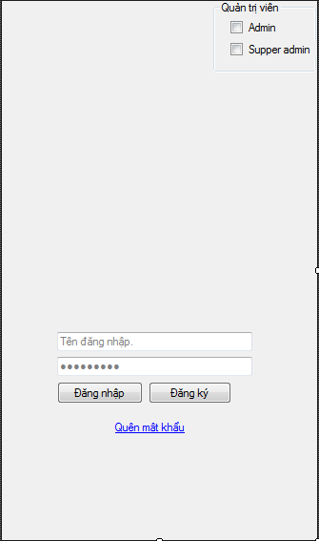
Demo login interface
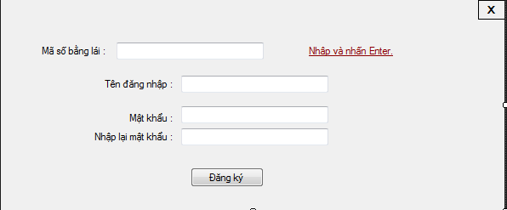
Demo register interface
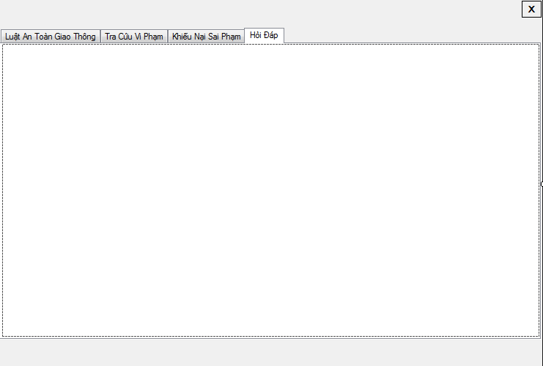
Demo user interface
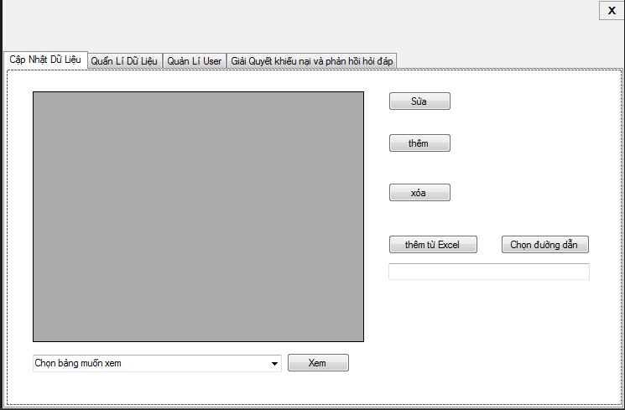
Demo admin interface

Specific Requirements

Functionality

Login function
- Description

UI | Login
Description | Open Login UI
Access UI | - Open the application
Screen
Section | Type | Data | Description
Username | Text Input |  | Input username
Password | Password |  | Input password
Login | Button |  | Confirm login
Register | Button |  | Open register form
Checkbox group | Group box |  | Select the login role
Action
Name | Description |  | Success | Fail
Login_action | Check password and username to login |  | Display user form | Notify failed
Forget_pass | Display recover pass form , follow the instructions to recover pass. |  | Notify new pass | Notify failed

Register function
- Description

UI | Register
Description | Open Register UI
Access UI | - Click register button in login UI
Screen
Section | Type | Data | Description
Username | Text Input |  | Input username
Password | Password |  | Input password
Check password | Password |  | Input password
Register | Button |  | Check register information
Action
Name | Description |  | Success | Fail
Leave_textbox | Check data in textbox |  | Change the note at the right | Change the note at the right
Register_action | Check data in textbox |  | Notify succeed and go to Login form | Notify failed

User function
- Description

UI | User
Description | Open user UI
Access UI | - Login system by Common user account
Screen
Section | Type | Data | Description
Traffic laws | Tag frame |  | Contain documents about traffic laws
Query | Tag frame |  | Contain Function about query data
Complain | Tag frame |  | Contain function about communication.
Ask and answer | Tag frame |  | Contain function about communication.
Action
Name | Description |  | Success | Fail
Log_out | Log out system |  | Return Login form | Stay here
Actions in the tag | Actions in tag include : query, read, send message, send complain,.. |  | Notify succeed | Notify failed

Admin function

- Description
UI | Admin
Description | Open Admin UI
Access UI | - Login system by Admin or Supper admin account
Screen
Section | Type | Data | Description
Update data | Tag frame |  | Contain function about insert datas.
Manage data | Tag frame |  | Contain Function about delete, repair datas.
Manager user | Tag frame |  | Contain function about insert, delete users.
Reply user | Tag frame |  | Contain function about communication with user
Manager admin(if login by supper admin account) | Tag frame |  | Contain function about manage admin.
Action
Name | Description |  | Success | Fail
Log_out | Log out system |  | Return Login form | Stay here
Actions in the tag | Actions in tag include : query data, show data, delete data , insert data, update data, reply user,.. |  | Notify succeed | Notify failed

Reliability and Security
- Password and secret answer when user register will be encode by MD5 encryption.

Backup and Restore
- Data in database can export to excel or word file to save and fill by excel when have malfunction system.

Interfaces

User Interfaces
- Common User will be use Login interface, register interface and user interface.
- Admin and supper admin will be use login interface and admin interface.

Hardware Interfaces
- To use interface computer must be use window operating system 32 or 64 bit.

Software Interfaces
- Excel, word will be use as a tool to insert and save data.
- Sqlserver is the main tool to save data systematic way.

Implementation

